Google Classroom

**Online Learning Platform**

Use-Case-Realization Specification: Complete Assignment

Version <1.0>

Revision History

| **Date** | **Version** | **Description** | **Author** |
| --- | --- | --- | --- |
| 5/12/2021 | 1.0 | Initial version | Nguyen Nhu Hong Phuc |
| 9/12/2021 | 1.1 | Edited version | Nguyen Nhu Hong Phuc |
|  |  |  |  |
|  |  |  |  |

Table of Contents

1. Introduction 2

1.1 Purpose 2

1.2 Scope 2

1.3 Definitions, Acronyms, and Abbreviations 2

1.4 References 2

1.5 Overview 2

2. Flow of Events—Design 2

3. Derived Requirements 2

Use-Case-Realization Specification: Complete Assignment

# Introduction

## Purpose

This Use-case Realization Specification provides an overview of how the corresponding use-case is realized to the design model in terms of collaborating objects.

## Scope

This document only applies to the Use-case: Complete Assignment

## Definitions, Acronyms, and Abbreviations

None

## References

## Overview

In part 2, the use-case realization will be further illustrated by using class diagrams and sequence diagrams. Later on, from the realized diagrams, other requirements that have not been considered in the design model will be listed in section 3 – Derived Requirements.

# Flow of Events—Design

There are four types of object this use-case realization. They include: Join View, Join Controller, Join Model which is a data access class. The sequence in which the operations are invoked is realized according to Model-View-Controller architecture.

## sequence diagram

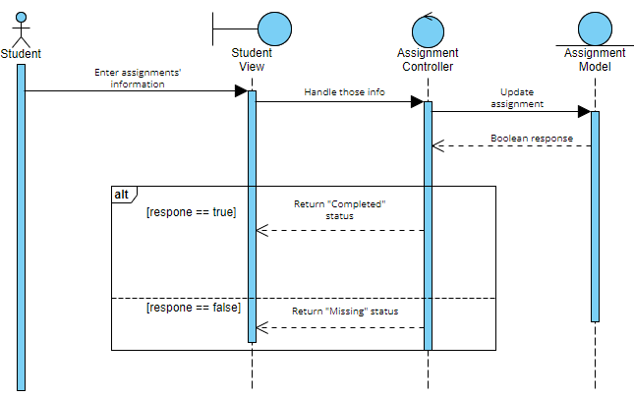

## class diagram

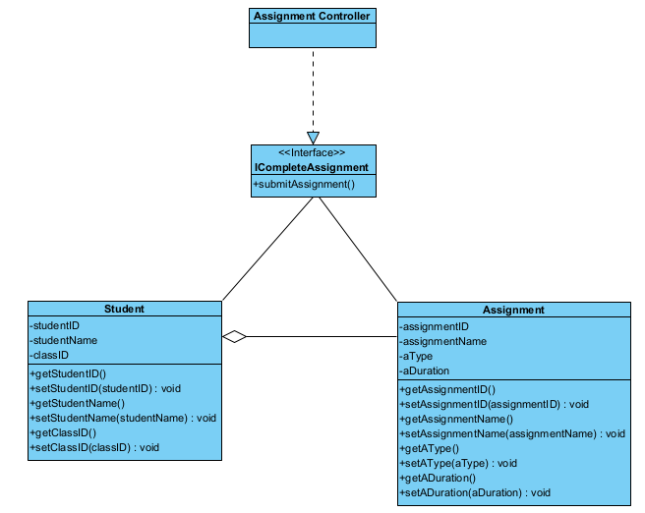

# Derived Requirements

After completing the assignment, the student receives the specific message.